Using groups of common textual features for authorship attribution

By John Olsson, Forensic Linguistics Institute; Nebraska Wesleyan University
It is well known that punctuation has the potential of being a successful attributor of authorship, but as Chaski (2005: 5) points out, it has only really been successful when combined on its own with an understanding of its syntactic role in a text. Chaski developed software for the purpose of punctuation-edge counting, lexical frequency ranking and part-of-speech tagging and demonstrated (Chaski 2001) that if punctuation were syntactically classified, it had a better performance in authorship attribution than simple punctuation mark counting (Chaski 2005: 4).
However, rather than analysing text syntax I chose to capitalise on insights regarding class of function word frequencies and combine these with punctuation counts. The software required is much easier to build and the results are easier to interpret and, I suggest, a lot easier to explain to juries and other lay persons. I will explain my rationale for this choice in the next section, since it does have some basis in theory.

Rationale for the test categories
The problems with attributing short texts are well known and easily explained: there is simply so little measurable data in a short text that measurements are generally unreliable. I believe that one reason punctuation is successful is because it has syntactic significance. It is not simply ornamental. The humble comma, for example, performs so many syntactic functions: it divides clauses - whether main clauses or dependent clauses - it separates noun phrases, it signals a break before a conjunction or after a conjunction, and so on. If you take almost any text the sum of punctuation marks is bound to exceed the frequency of any single word. In addition to syntactic significance, therefore, punctuation has a statistical function: we have, at least, one class of item which is almost bound to occur in sufficient quantities to enable successful measurement.
This idea of punctuation acting as a measurable group led me to think about what kinds of words, or other elements in a text, could be grouped together to offer reliable, consistent inter-author and intra-author data. Of course, it is possible to measure almost anything in a text - but not only does any such measurement have to be relevant, it should have some basis in theory too. I wondered, therefore, what categories of word could be measured which would have some rationale in authorship attribution. This is because if Chaski is correct in applying syntactic theory to punctuation analysis (and other categories) – and I believe she is correct – then there would have to be a syntactic, or at least theoretical, basis of some kind to justify the inclusion of any group of items or words as test markers.
I began by thinking about the traditional eight 'parts of speech' with which many of us will be familiar from our school days, viz. nouns, verbs, adjectives, interjections, etc.
I then thought about any possible basis for simplifying these eight groups: we could hypothesise that 'originally' (whenever that was) words were simply divided into two groups – things and actions, i.e. nouns and verbs or, perhaps more accurately, proto-nouns and proto-verbs. Adjectives, for example, would – structurally at least – probably have derived from the proto-noun group and determiners, which in all probability followed later, would also form part of this group. Similarly, all the other categories of word probably stemmed from these two proto-groups.
Reverting to ideas formed in classical generative theory I considered the hypothesis that verbs and prepositions share common features which nouns and verbs do not – at a structural, syntactic level (not at the semantic or morphological levels). This was an idea originally explored in a theory known as X' (or X-Bar) theory. This led me to devise – as a preliminary step – software which would count verbs and words which were structurally related to verbs – such as prepositions – on the one hand, and nouns and determiners – which were, intuitively, noun-related as opposed to being verb-related, on the other. In this way I hoped to find out, as an early form of marker, whether a text was primarily 'verb-oriented' or 'noun-oriented'.
However, counting verbs is not easy: in English many verb and noun forms are identical. And even if prepositions are not structurally related to verbs they are also difficult to count in any meaningful way. For one thing, they are structurally polyfunctional – the word 'to', for example, is not only the infinitive particle, and a preposition, it is also frequently found in phrasal verbs).
I therefore turned my attention to the 'noun' end of what I am referring to as the proto-word spectrum. Determiners are definitely noun-related words and are very easy to count. Cumulatively, they have the practical advantage of giving a very good representation of the percentage of nouns in a text. On the other hand, conjunctions are - at least in English - neutral in terms of proto-word relationships. They certainly have a structural function, and are sometimes complementary to punctuation.
It seemed to me that the combination of these three groups – punctuation, determiners and conjunctions – offered a wide cross-section of what texts consist of, although by no means a comprehensive one. They each have important syntactic relevance, and the combination of counts of the three types of element means that any tests based on their use would offer data which was numerically representative of the text.

Method
I counted punctuation under eleven different categories, from full stops to paragraph marks and, further, grouped, sentence enders (stops (periods), question marks and exclamation marks) as an additional category.
Additionally, I counted a set of conjunctions and a set of determiners.
Altogether, therefore, there were 13 categories, given as follows:

List of categories for testing
Stops
Commas
Question Marks
Exclamation Marks
Paragraphs
Brackets
Dashes
Sentence Enders
Colons
Semi Colons
Hyphens
Conjunctions
Determiners

Each category is computed for its density in the text by the simple expedient of dividing the number of instances of it by the text length. Thus, 3 commas in a 100 word text would give a density of 0.03.
Attribution is made on the basis of which of two known-author texts has the greater number of categories closer in density to the questioned text.
Originally, the counting of categories was on a strictly numerical basis, i.e. if one candidate had 7 categories and the other 3 categories then the candidate with the greater number of categories closer to the respective categories in the questioned text was deemed to be the more probable author.
However, this method had the disadvantage of ignoring the respective 'weight' of each category. Thus, a candidate with, for example, a closer correspondence in several minor categories, such as exclamation marks and hyphens, might – apparently accidentally – be chosen by the software as the more probable candidate simply on the basis of these minor categories having a closer correspondence in the known text to the questioned text than those of the other candidate who – on the other hand – might have a closer correspondence with the major categories, such as paragraph length, number of stops (periods), etc.
It therefore became evident that a better method of computing the results was desirable. Hence, the number of closer categories was combined with their respective frequency in the text to yield a combined weighted result for each author pair comparison.

Method of text comparison
For simplicity sake it was decided to test texts in pairs of known texts with a single questioned text. For each author pair a text was chosen as the 'questioned' text. This text was then compared with one each of the known author pairs. Where authors had more than one known comparable text (topic, length, genre, text type) to choose from, then each of these was tested in turn. The simplest way for the software to do this is to place the texts into three groups: the questioned text, or texts, and known texts from both candidate one and candidate two.
The illustration below shows the three text sets, each in its own folder on the computer. The software then cycles through each text in each of the three folders. Thus if there is one questioned text and 15 known texts from each of two candidates the software will make 225 comparisons (see below):
Figure 1: Screenshot of the three folders (one questioned and two known):
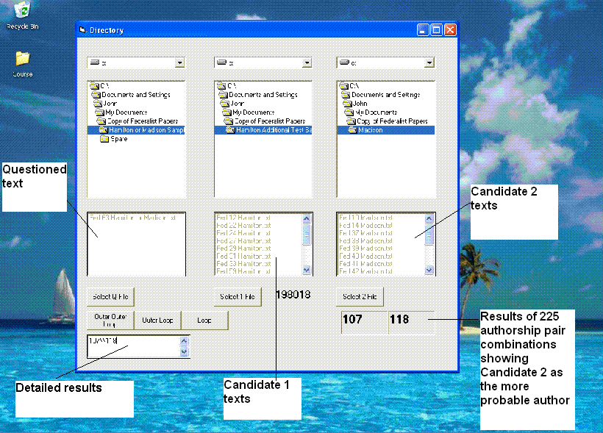

The test bed
I decided to test three corpora of texts. The first set would be to discover, overall, whether the method was viable. The second would be to attempt to verify the results of the first, while the third would be an actual test.
From the outset the focus would be on shorter texts, but it was also necessary to determine whether the method would give accurate results for longer (but not very long) texts. For example, some of the texts in the Chaski corpus were very short indeed - one is a mere 190 words or so in length. On the other hand, there are texts in the Federalist Papers which are more than 3,000 words in length.

The corpora
The first corpus is from Chaski's own database (Chaski 2001). This consists of the eleven texts referred to in Chaski's article, copies of which are included in that publication. I decided to take one text from each of the four authors (referred to as 001, 009, 016 and 080) as the questioned text for that author, and compare each 'questioned' text with every other text from each author. Thus, to begin with, Author 001's first text (001-01) was compared with Author 009's texts: 01, 02 and 03, using – respectively – Author 001's 002 and 003 as the known texts in that 'mini-inquiry'. Author 001's text 01 was then compared with Author 016's two texts, 001 and 002, again with 001's 02 and 03 - respectively - as that author's known texts. Hence, each author in the inquiry was compared with every other author, giving a total of 29 text pair comparisons in all.
The second corpus consists of texts all available from the Internet. The first group within this corpus consisted of texts by Elizabeth Barrett Browning, the anonymous nineteenth century author of 'An Englishwoman's love letters' and a number of letters by Maria Edgeworth. These writers were all contemporaries or near contemporaries, and the text type in each case is of the genre known as 'love letter'. Moreover, the texts were chosen because a number of the topics in the letters are common to all of them, such as the writers' views on jewellery, places to which they had travelled, and comments on being published.
The second group within the second corpus is a set of letters written by young Japanese-descended internees during World War Two. They are all written to one person, the librarian of their common home city (San Diego), and are very similar in topic: conditions in the internment camp, work duties, concerns for family, items requiring to be purchased, such as clothing, books, etc.
The third group within the second corpus consists of a set of letters written by a young soldier to his mother and these are compared with the writings of his younger brother to him. Again, many of the topics are in common. The fourth group consists of letters home from two soldiers who, though in the same military unit, were apparently unknown to each other. These third and fourth groups referred to were written during World War Two. The writers are all American.
The fifth group in the second corpus consists of letters to a young World War One British soldier on the Front from his parents. Two letters from his father and two letters from his mother form the known texts, and one letter from his mother functions as the 'questioned' text.
The sixth group is a set of emails from two members of the Forensic Linguists' List which were published on the list, and are thus not confidential.
The seventh and last group is taken from a blog known as 'Three Girls Grown Up'. The writers are all young women who, it appears, have been close friends since childhood, or at least for a number of years. The topics are all concerned with taking a humourous view of life's ups and downs, and concern common topics such as work, relationships, pets, etc.

The third corpus is a set of texts from the Federalist Papers. As readers will be aware there are 11 disputed Federalist Papers, which were either written by Madison or Hamilton. A number of distinguished studies have been published on this particular attribution problem over the years, the most famous being Mosteller and Wallace's study of 1964. Because the software was designed for very short texts I tested only a sample of these texts (the software performing rather slowly for long texts). In ten of the eleven questioned texts I used 10 each of Hamilton's texts and Madison's texts as the known texts, but in the case of Paper 63, having obtained a neutral result I expanded the test bed to include 15 papers from each author, in an attempt to avoid a neutral result. Texts from both Madison and Hamilton were chosen entirely at random.
All of the texts used in this study (or links to them), and all of the detailed data and results are published with this paper. The results are given in an Excel file (see link).

The results: first corpus
In the case of the first corpus, consisting of 11 texts by four authors (as published in Chaski's 2001 paper) there were 29 possible author pair comparisons to be made. The software yielded the following results:

Texts | Correct | False
1/9 | 6 | 0
1/16 | 4 | 0
1/80 | 5 | 1
9/80 | 5 | 1
9/16 | 4 | 0
16/80 | 3 | 0

(1/9 means a comparison between author '001' and author '009').

In this corpus 27 of the 29 text pairs were correctly attributed, yielding an accuracy rate of 93 %. As importantly, all 6 author pairs were cumulatively correctly attributed, yielding a 100% authorship result. For example, in the case of the comparison between author 1 and author 9 there were six text pairs to test: each pair tested successfully – but in the case of author 1 and author 80 only 5 of the six tests attributed correctly. Thus, cumulatively, the attribution exercise was successful between those two authors. A stated above, all authors were correctly attributed cumulatively.

The results: second corpus
The second corpus consisted of nine different author pair groups. Of these nine groups only one failed to attribute correctly, and of the 39 text pair comparisons, 33 attributed correctly. Thus the text authorship accuracy rate (the number of texts correctly attributed) was at 85%, while the author authorship accuracy rate (the number of authors cumulatively correctly attributed) stood at 89%.

The results: the third corpus
The test bed consisted of 10 samples each from Madison and Hamilton and the eleven questioned texts. For the last of these (Paper 63) a neutral result was obtained, and so the test bed was expanded to 15 texts from each author.
All eleven texts were attributed to Madison, which concurs with the findings of Mosteller and Wallace (1964) and other writers.

The method: advantages and limitations.
The method is successful even with short texts. However, it is necessary for there to be at least two known texts from each candidate for the test to be successful, and preferably three texts. This is because, as is generally found, not every short text is a representative sample of an author's work. Where there is a group of texts to test, the test successfully discriminates, on average, 94% of the time. Where there are single texts, the test successfully discriminates 92.3% of the time.

Conclusion
The test is easy to administer and the software which carries out the work is reliable and robust, although it is slower in performance with longer texts (over 1500 words).
The actual method used on which to base the authorship attribution can still be refined and improved with further testing. However, the basic idea of grouping categories of elements (punctuation, conjunctions, determiners) seems sound in practice, although it can be improved and expanded upon. At a later stage I hope to find the relationships between densities of punctuation and certain classes of word in a text. For example, one intuitively feels that there must be a relationship between punctuation and conjunction density, and measurements of this relationship – if there is one – will be made in the near future, using a large corpus. In the meantime, the search goes on for further categories, and for understanding the nature of the relationship between these categories. Further tests and developments to improve the software are also being carried out at the Forensic Linguistics Institute. It is hoped to make a Beta version available soon.

Bibliography:
Burrows, J. “Word-patterns and Story-shapes: The Statistical Analysis of Narrative Style.” Literary and Linguistic Computing, 2(2) (1987), 61–70.
Chaski CE 2005. EMPIRICAL EVALUATIONS OF LANGUAGE-BASED AUTHOR IDENTIFICATION TECHNIQUES. International Journal of Speech, Language and the Law. 8 (1), 1-65.
Chaski CE 2005. Who’s At The Keyboard? Authorship Attribution in Digital Evidence Investigations. International Journal of Digital Evidence 4 (1) 1-13.

Sources:
Elizabeth Barrett Browning's letters: www.gutenberg.org/files/16646/16646-h/16646-h.htm
'An Englishwoman's Love letters': http://books.jibble.org/1/5/9/4/15941/15941-8/AnEnglishwomansLove-LettersbyA-0.html
The Letters of Maria Edgeworth: http://onlinebooks.library.upenn.edu/webbin/gutbook/lookup?num=8825
Letters to Miss Breed from young Japanese-descended internees in World War Two: http://www.janm.org/exhibits/breed/title.htm
Three girls grown up together: www.wendy.com/letterwriting
The Moorhouse Slack letters: www.eriding.net/worldinconflict/cecilslack/index.shtml
The Federalist Papers: www.gutenberg.org/etext/18

